Week 8 MOS Reset and Temperature Tests
October 17 results for the October 20 mentor discussion
Team Member: Henan | Week 8 | October 17, 2026
Course: AMS Senior Design | Project: Programmable Bias Voltage DAC

Selected block: Capacitor DAC array
Completed work: physical MOS reset and its simulations; three-temperature TT corner scan.

Question 1
Based on the overall specifications you set for your project, what specifications should this block meet?
The current test vehicle is a 3-bit CDAC with a 1 V reference span and 125 mV nominal LSB. Its reset must discharge Vout toward the lower reference without excessive release error or output-span change. I used the provisional ±61 µV precision band as a diagnostic comparison, not an approved reset requirement. The future 12-bit targets, including 10 µs settling and 1 ms retention, are not demonstrated by this test.

Question 2
What simulations do you need to run to verify this block meets those specifications?
I compared ideal relay reset with NMOS reset at W=1 µm and 0.5 µm, L=60 nm, measuring codes 000, 100 and 111. A second reset pulse from 350 to 370 ns tested discharge from the code-111 output. I then ran tt_lib at −40, 27 and 85 °C with W=0.5 µm and compared code 111 near 343 ns. Pending tests include numerical convergence, full-code temperature errors, temperature-dependent reset timing, loaded settling, retention and power.

Question 3
Why is this block a proper selection for your application and your overall specifications?
Physical reset exposes a device-size trade-off in the CDAC. Reducing W from 1 to 0.5 µm decreased the three sampled error magnitudes by approximately 44–46%; the smaller device also discharged a high output near zero. The temperature scan retained the expected sequence and gave a 179.9 µV code-111 spread across the three sampled temperatures. These results motivate further precision work, but do not demonstrate cryogenic operation or system-level power benefits.

Question 4
What are the main challenges in designing this block?
At W=0.5 µm, the code-000 and code-111 differences versus ideal reset are about −184.23 and −546.0 µV. A charged-node test reached +3.11 µV before release and −184.57 µV afterward. At approximately 343 ns, code-111 output decreases from 874.4884 mV at −40 °C to 874.3085 mV at 85 °C. Discharge accuracy, release offset and temperature sensitivity therefore require separate budgets. The physical contributions and numerical sensitivity remain unresolved.

Question 5
What circuit- or system-level solutions address those challenges?
I preserved the ideal-reset reference, compared two reset widths and retained W=0.5 µm for the temperature scan. Further circuit changes are deferred until the October 20 mentor discussion. We need to agree reset error/timing and temperature-error budgets, then choose whether to prioritize sizing, compensation or another reset topology. Full-code and loaded/hold tests should follow; cryogenic conclusions require validated cold models.

Implementation and test conditions
I recovered the six-TG schematic and backed up the historical netlist. The recovered cell is cdac_3b_n65_tg_recover_oct17. The MOS variant is cdac_3b_n65_tg_mosrst_oct17: reset D=Vout, G=rst, S=Vl, B=VSS; L=60 nm, nf=m=1. The ideal reference uses W6 relay. An initially misbound reference run was excluded after netlist inspection; the corrected reference contains the relay and no reset NMOS.
Spectre, tt_lib; reset comparisons at 27 °C, followed by a temperature-only scan at −40/27/85 °C. VDD=Vu=1 V and VSS=Vl=0 V; no added output load. Eight 110.659 fF unit capacitors form the C:2C:4C array plus dummy. Six reference TGs are unchanged. Driver: initial reset release 20 ns; make events 35+40k ns; dead time 5 ns; edges 1 ns; stop 400 ns. Reference voltages and control drive remain ideal.

Mentor discussion and work status
No new mentor response was received during fall break. For Tuesday October 20: agree reset release and temperature-error budgets; weigh reset speed against device loading; choose the next verification or circuit remedy. The original ±61 µV band remains provisional and does not define a measured temperature-drift specification.
This week’s work is complete for reporting. The conservative/maxstep=100 ps rerun was proposed but not performed. The TT temperature scan is complete, but full PVT, mismatch, PEX, hold-drift, power and cryogenic qualification remain open. The companion hold module remains unbuilt. No further reset changes are planned before mentor discussion.

Reset width comparison
The corrected ideal-reset result is near numerical zero after the initial reset release. The 1 µm reset measured about −329.75 µV at that release. The table compares later code plateaus; ΔV means MOS minus the ideal reference.
Code | Ideal Vout  (mV) | W 1 µm  Vout (mV) | W 0.5 µm  Vout (mV) | ΔV 1 µm  (µV) | ΔV 0.5 µm  (µV)
000 | 0 | −0.3300194 | −0.1842289 | −330.0194 | −184.2289
100 | 499.9988 | 499.2665 | 499.6032 | −732.3 | −395.6
111 | 875.0047 | 873.9878 | 874.4587 | −1016.9 | −546.0
Displayed sample times (ns), codes 000/100/111: ideal 59.0000/223.1147/343.9046; W=1 µm 59.97974/223.0882/343.8997; W=0.5 µm 59.57447/223.1007/343.9020. Times are slightly unequal and values come from rounded marker readouts. These are initial comparisons, not converged INL/DNL results.
Absolute error decreased by 44.2%, 46.0% and 46.3% at the three codes. After removing the zero-code offset, endpoint span reduction is approximately 0.07850% for W=1 µm and 0.04135% for W=0.5 µm. Reset-device parasitic loading is a possible explanation for the span change, but the physical contributions are not isolated.
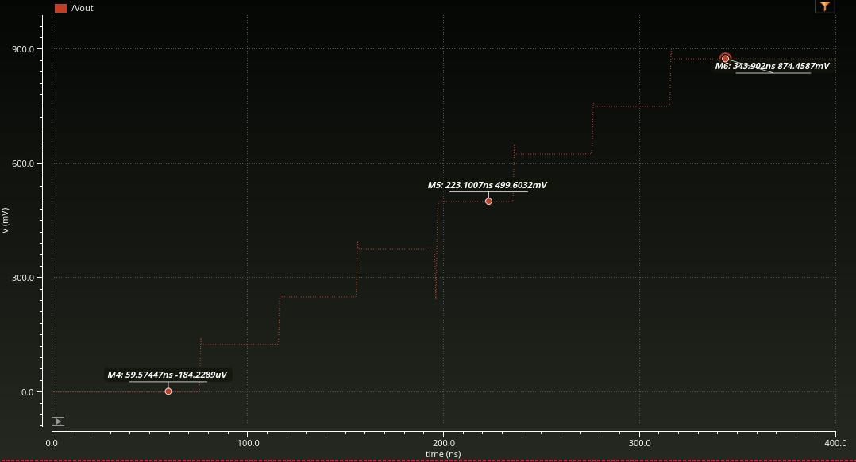
Figure 1. W=0.5 µm ascending scan. Marker values are transcribed above; only the reset width was intentionally changed from the 1 µm comparison.

Charged output reset and release
The test driver applies a second reset pulse from 350 to 370 ns with 1 ns edges and holds the bottom-plate code at 111. This tests discharge and release disturbance; it does not restore the original bias or demonstrate refresh operation.
Time (ns) | Vout | Interpretation
348.9924 | 874.4486 mV | Charged output before reset
368.9987 | +3.108614 µV | Near zero while reset is on
374.3853 | −184.574 µV | Residual offset after release
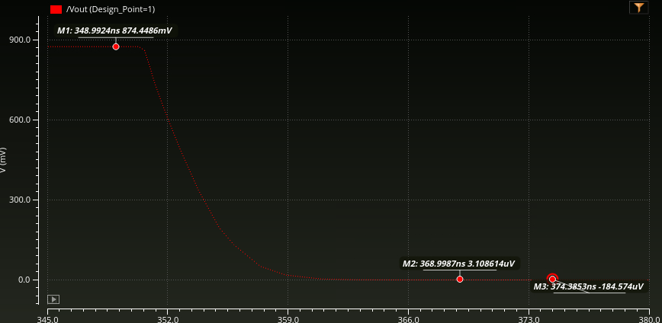
Figure 2. Charged-output discharge and post-release offset with W=0.5 µm.
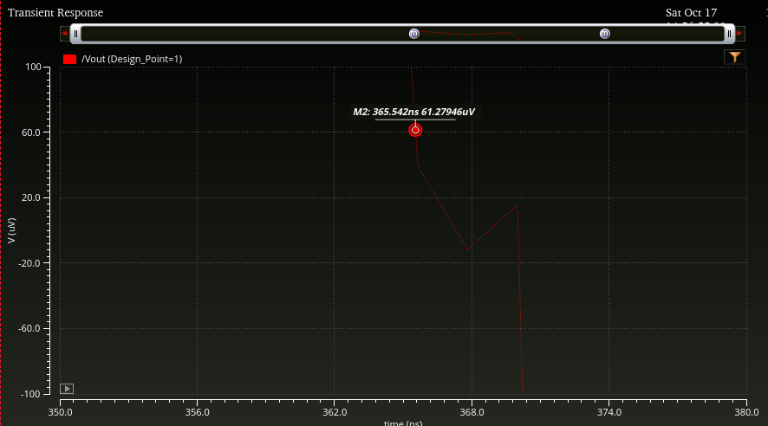
Figure 3. Near-threshold marker at 365.542 ns and +61.27946 µV, about 15.54 ns after the reset assertion command. This is slightly outside +61 µV; it is an approximate threshold time, not an exact settling measurement. The zero-region zigzag requires numerical verification. The band is left again after reset release.

Temperature corner scan
I ran TT_m40, TT_27 and TT_85 in ADE Assembler with tt_lib at −40, 27 and 85 °C. Nominal was disabled to avoid an extra run. The MOS-reset circuit (W=0.5 µm), 1 V references, no-added-load setup and reset-test driver were otherwise unchanged. All three runs completed and displayed the expected staircase and second reset.
Temperature | Vout at code 111  near 343 ns (mV) | Difference from  27 °C (µV)
−40 °C | 874.4884 | +31.4
27 °C | 874.4570 | 0
85 °C | 874.3085 | −148.5
The sampled maximum-to-minimum spread is 179.9 µV. The 27 °C and 85 °C markers are at 343.0198 and 343.0218 ns. The −40 °C value was confirmed from the marker by the user at approximately 343 ns; its exact time was obscured. These final readings supersede the earlier unequal-time 163.5 µV comparison.
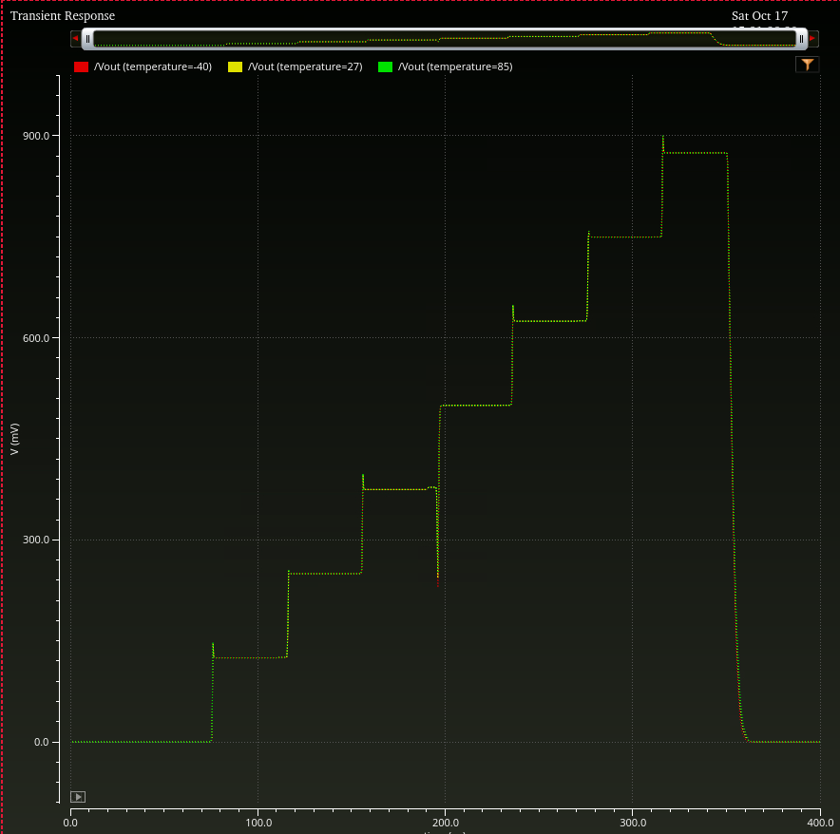
Figure 4. Vout overlays at −40 °C (red), 27 °C (yellow) and 85 °C (green). Full-scale overlap shows sequence operation; the table quantifies differences that this scale does not resolve.
Interpretation: code-111 output falls across these three sampled temperatures. This is one-code finite-delay temperature sensitivity, not a full-range temperature coefficient, all-code INL/DNL, long-term hold drift or full PVT qualification. Reset timing and post-release offset were not quantified across temperatures. Model temperature validity and numerical convergence have not been independently established; no cryogenic validation is claimed.

